**Week-1 Assessment**

**Project:** Plant disease detection system for sustainable agriculture🌿

**Project by:** *K. Ram Sai Prakash*

Edunet Foundation

**Problem Statement:**

Design a Convolutional Neural Network (CNN)-based system capable of identifying and classifying plant leaf diseases across different crop types such as apple, cherry, grape, and corn. The model should be able to distinguish between healthy and infected leaves, as well as recognize the exact disease present. This tool will support precision farming by enabling early disease identification and promoting effective crop treatment strategies.

**Pipeline:**

1. 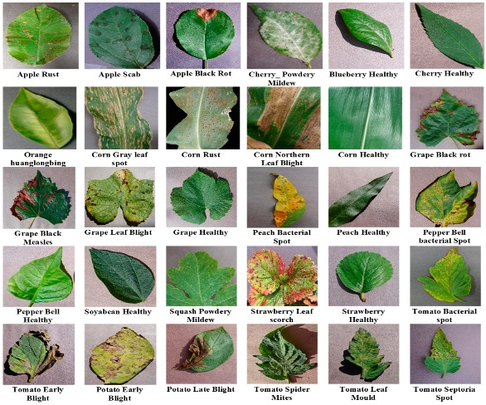**Dataset Preparation:**  
   Images are organized into structured folders for training, validation, and testing. Each folder contains subcategories based on different disease types or healthy status for each crop.
2. **Zipping & Colab Integration:**  
   The dataset is compressed into a ZIP file and stored on Google Drive. In Google Colab, the Drive is mounted, and the dataset is extracted using Python commands to make it accessible for further processing.
3. **Image Preprocessing & Augmentation:**  
   All input images are resized uniformly (e.g., 128x128 pixels). Augmentation techniques such as rotation, flipping, and scaling are applied to enhance the dataset and improve the model’s ability to generalize.
4. **Model Development with CNN:**  
   A Convolutional Neural Network is constructed and trained on the preprocessed images. The model learns patterns associated with each disease class through multiple convolutional and pooling layers.
5. **Model Testing & Performance Analysis:**  
   The trained model is evaluated using the test set. Performance is assessed using various metrics to measure the model’s accuracy and effectiveness in detecting and classifying plant leaf diseases.